Pimpri Chinchwad Education Trust’s

**Pimpri Chinchwad College of Engineering**

**Department of Computer Engineering**

**Project Report**

on

**“*CAR RENTAL SYSTEM*”**

under

# Project Based Learning – II

Academic year 2021-22

Submitted by

SYCOC324 Pratiksha Satapure

SYCOC326 Divya Sawant

SYCOC339 Rutuja Tallapalli

**Index**

1. Title of project
2. Abstract
3. Introduction
4. Software Requirement Specification
5. Scope
6. Functional Requirements
7. Non-Functional Requirements:
8. Conceptual Design using ER features
9. Conceptual Design using ER features
10. UML Design
11. Graphical User Interface
12. Source Code
13. Conclusion

**Title of project: *Car Rental System***

**Abstract:**

The Car Rental System is being developed for customers so that they can book their vehicals.This application takes information through filling their details. A customer being registered in the website has the facility to book the vehicle which he requires.

The proposed system is completely integrated online system. It automates manual procedure in an effective and efficient way. This automated system facilitates customer and provides to fill up the details according to their requirements.

**Introduction:**

The “Car Rental System” has been developed to override the problems prevailing in the practicing manual system. This software is supported to eliminate and in some cases reduces the hardships faced by the existing system. Moreover this system is designed for the particular need of the company to carry out operations in as smooth and effective manner.

The application is reduced as much as possible to avoid errors while entering the data. It also provides error message while entering invalid data. No formal knowledge is needed for the user to use this system. Thus by this all it proves it is user-friendly. Car Rental System, as described above, can lead to error free, secure, reliable and fast management system. It can assist the user to concentrate on the record keeping. Thus it will help organisation in better utilization of resources.

Every organization, whether big or small, has challenges to overcome and managing the information of Car Company, Car Booking, Payment, and Customer. This is designed to assist in strategic planning, and will help you ensure that your organization is equipped with the right level of information and details for your future goals. Also for those executives who are always on the go, our systems come with remote access features, which will allow you to manage your workforce, at all times. These systems will ultimately allow you to better manage resources.

**Software Requirement Specification:**

The Software Requirement Specification is produced at the culmination of the analysis task. The function and performance allocated to software as a part of system engineering are refined by establishing a complete information description, a detailed functional and behavioural description, an indication of performance requirements, appropriate validation criteria, and other data pertinent requirements.

**The proposed system has the following requirements:**

* System needs to store information about new entry of Car.
* System needs to keep the information of Car Company.
* System needs to maintain quality record.
* System needs to update and delete the record.
* It also needs a security system to prevent data.

**How Car Rental System Services Work:**

A car rental is a vehicle that can be used temporarily for a period of time with a fee. Renting a car assists people to get around even when they do not have access to their own personal vehicle or don’t own a vehicle at all. The individual who want to rent a car must first contact the car rental company for the desired vehicle. This can be done online. At this point, this person has to supply some information such as; date of rental, and type of car. After these details are worked out, the individual renting the car must present a valid Identification Card.

Most companies throughout the industry make a profit based on the types os car that are rented. Customers are free to choose any car of their choice based on their purse and availability of such car at the time or reservation.

Thus this is how the online car rental system will works.

**Scope:**

This project traverses a lot of areas ranging from business concept to computing field, and required to perform several researches to be able to achieve the project objectives. The area cover includes:

* Car rental industry: This includes study how the car rental business is being done, process involved and opportunity that exists for improvement.
* General customers as well as the company’s staff will be able to use the system effectively.
* Web- platform means that the system will be available for access 24/7 except when there is temporary server issue which is expected to be minimal.

**Benefits of Online Car Rental Services:**

* This online car rental system is fully functional and flexible.
* It is very easy to use.
* This online car rental system helps in back office administration by streamlining and standardizing the procedures.
* It saves a lot of time, money and labour.
* Eco-Friendly: The monitoring of the vehicle activity and the overall business becomes easy and includes the least paper work.
* The software acts as a office that is open 24/7.
* It increases the efficiency of the management at offering high quality servives to customer.
* It provides custom features development and support with the software.

**Functional Requirements:**

Requirement analysis is a software engineering technique that is composed of the various tasks that determine the needs or conditions that are to be met for a new or altered product, taking into consideration that possible conflicting requirements of the various users.

Functional requirements are those requirements that are used to illustrate the internal working nature of the system, the description of the system, and the explanation of each subsystem. It consists of what task system should perform, the processes involved, which data should the system holds and the interfaces with the user. The functional requirements identified are:

1. Customer’s registration: The system should allow users to register online.
2. Online reservation of cars: Customers should be able to use the system to make booking and online reservation.
3. Automatic update to database once reservation is made or new customer is registered: Whenever there’s a new reservation or new registration, the system should be able to update the database without any additional efforts from the admin.

**Non-Functional Requirements:**

It describes the aspects of the system that are concerned how the system provides the functional requirements. They are:

1. Security: The subsystem should provide a high level of security and integrity of the data held by the system, only authorized personnel of the company can gain access to the company’s secured page on the system; and only users with valid password and username can login to view user’s page.
2. Performance: The system should have high performance rate while executing user’s input.
3. Error handling: Error should be considerably minimized and an appropriate error message that guides the user to recover from the error should be provided. Validation of user’s input is highly essential. Also standard time to recover from an error should be 15 to 20 seconds.
4. Availability: This system should always be available 24/7. Also in the occurrence of any major system malfunctioning, the system should available in 1 to 2 working days, so that the business is not severely affected.
5. Ease to use: Considering the level of knowledge possessed by the users of this system, a simple but a high quality user interface should be developed to make it easy to understand and requires less training.

**Conceptual Design using ER features**

The following is the ER diagram for Car Rental System

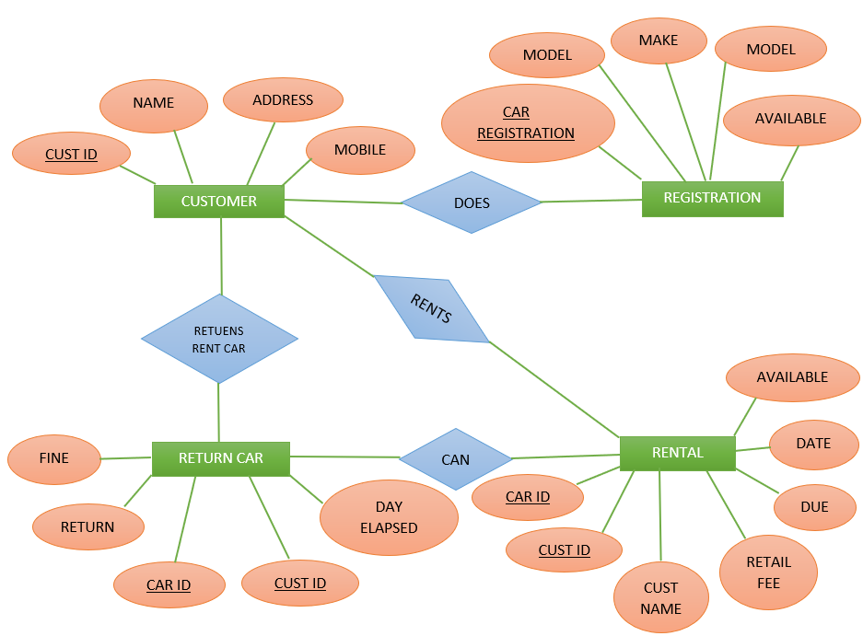

**UML Design**

1. **Use Case Diagram**

CAR RENTAL SYSTEM

**`**

CUSTOMER

ADMIN

The Car Rental System has two active users Customers and Admin. Customer can login, register, take a car on rent and return car. Admin can login, update car details, add car, delete a car.

1. **Activity Diagram**
2. Member Registration

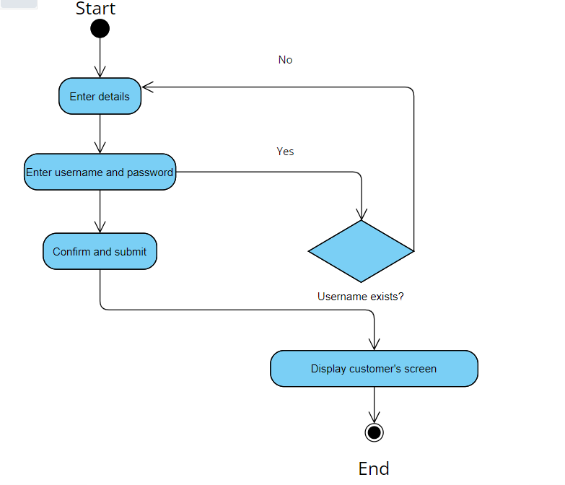

1. Reservation of car

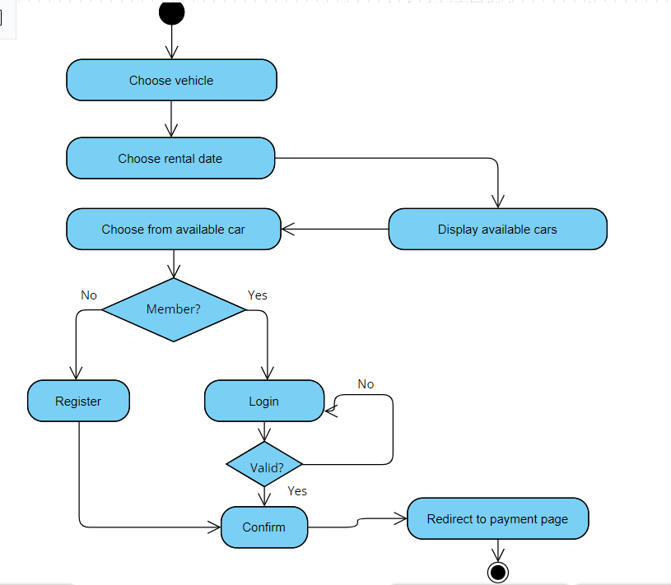

1. Rent a car

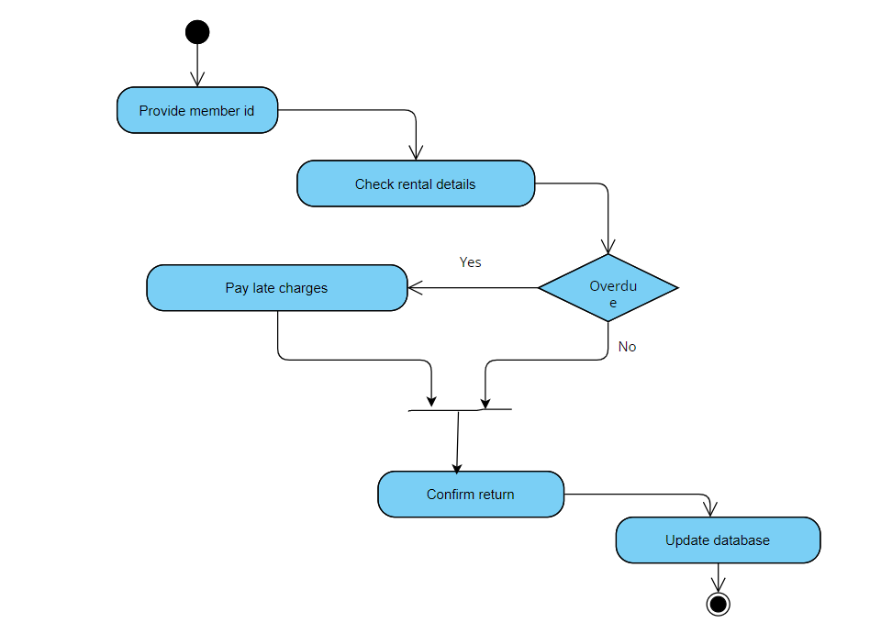

1. Adding a new car

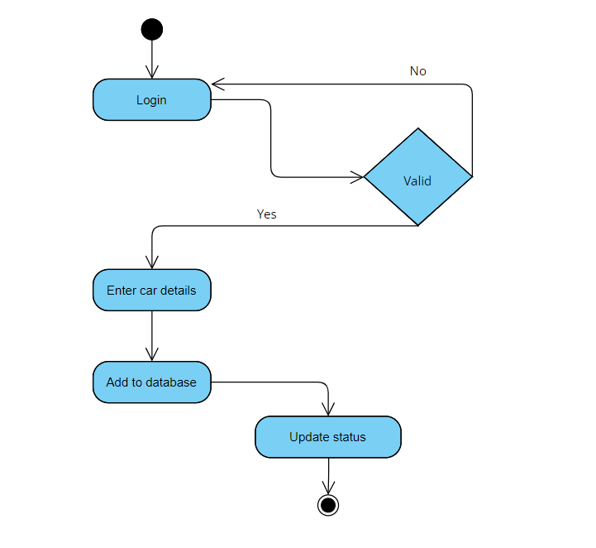

1. **Sequence Diagrams**

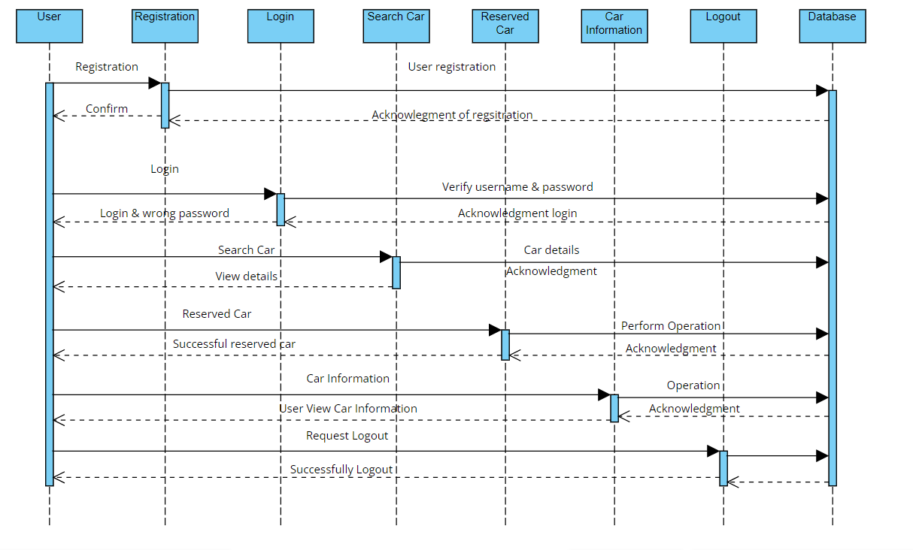

1. **Class Diagram**

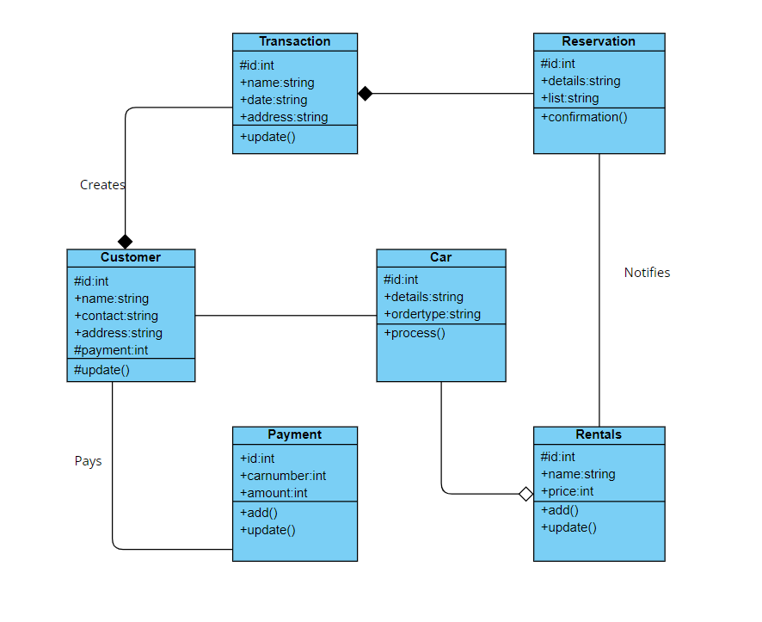

**Graphical User Interface**

Introduction to MYSQL

MYSQL is a relational database management system (RDBMS) that runs as a server providing multi-user access to a number of databases. The MYSQL development project has made its source code available under the terms of the GNU General Public License, as well under a variety of proprietary agreements.

All major programming languages with the language specific APIs include Libraries for accessing MySQL databases. In addition, an ODBC interface called MyODBC allows additional programming languages that support the ODBC interface to communicate with a MySQL database, such as ASP or ColdFusion.

Introduction to ECLIPSE IDE

The Eclipse platform which provides the foundation for the Eclipse IDE is composed of plug-ins and is designed to be extensible using additional plug-ins. Developed using Java, the Eclipse platform can be used to develop rich client applications, integrated development environments and other tools. Eclipse can be used as an IDE for any programming language for which a plug-in is available.

In our project we have used Eclipse IDE with MySQL to connect databases.

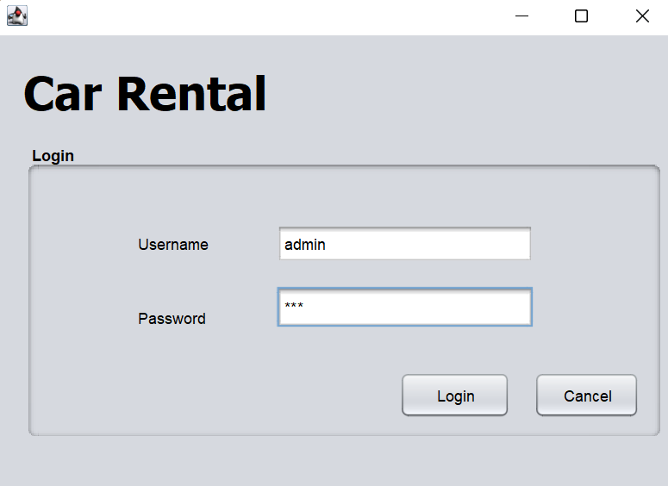

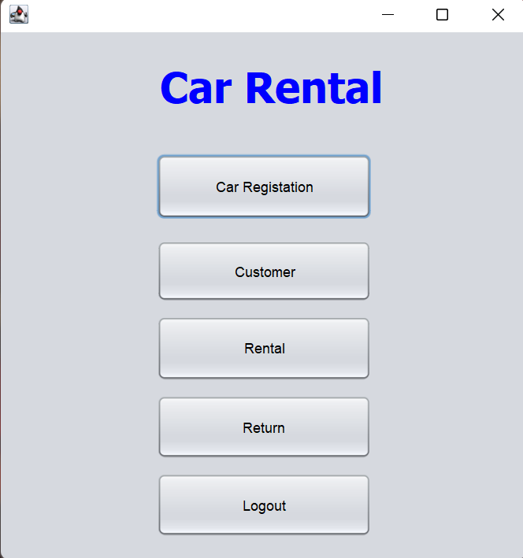

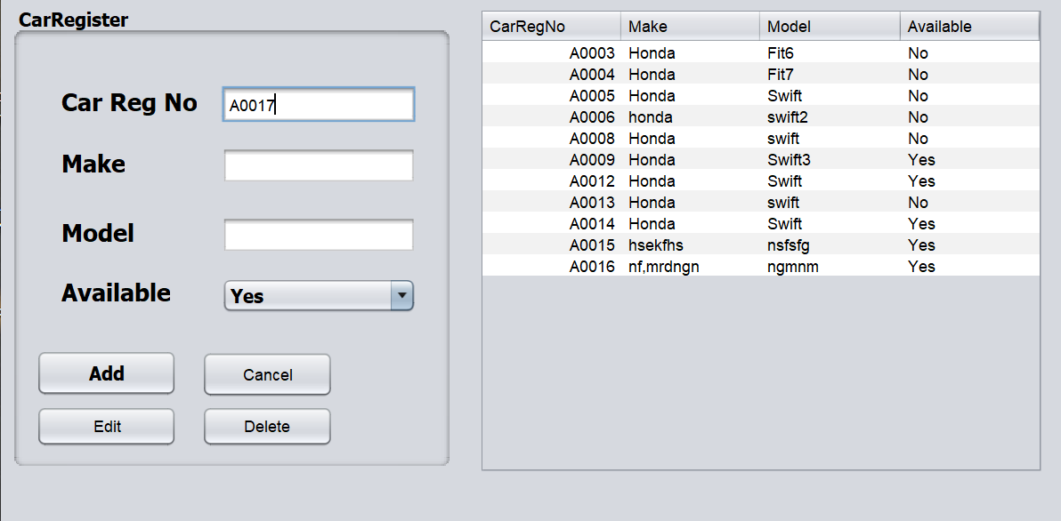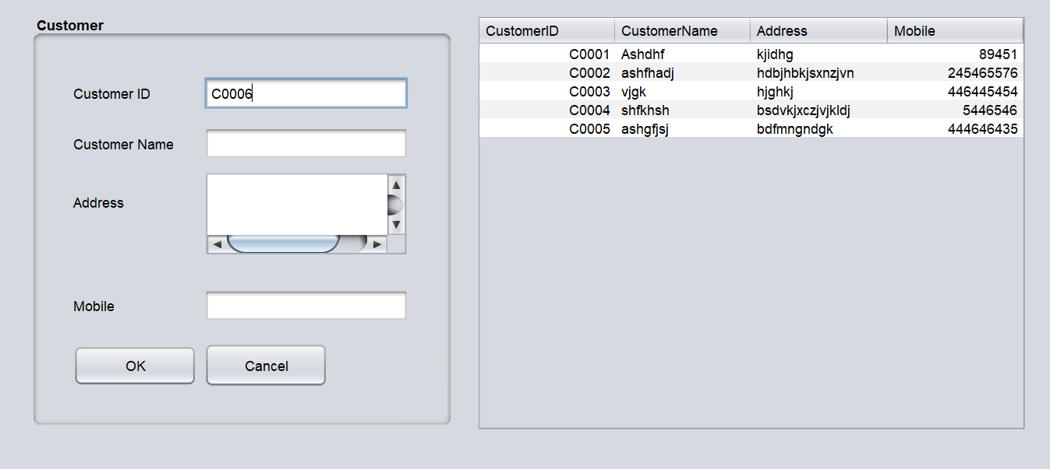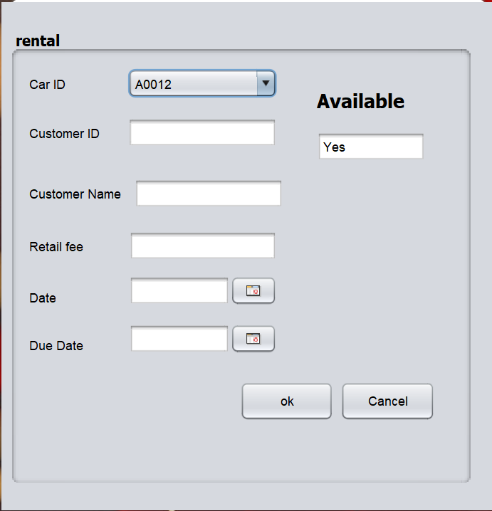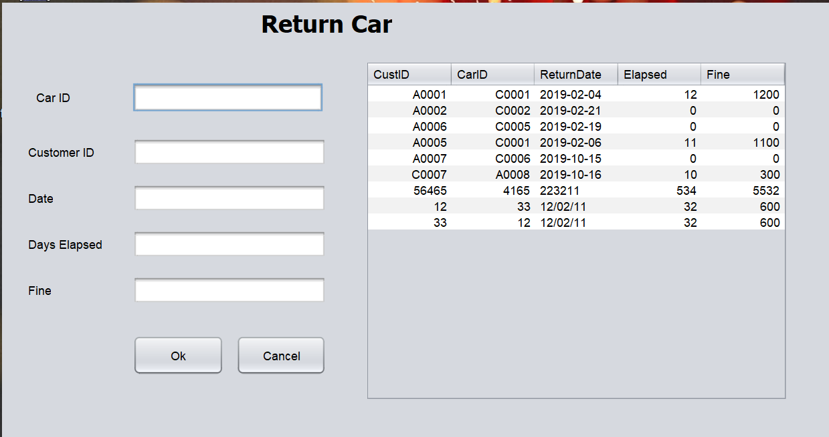

**Source Code**

* Software Engineering book-R.S.Pressman
* JavaScript By McGraw Publication
* <https://www.tutussfunny.com/car-rental-system-project-in-java/>
* https://code-projects.org/rental-management-system-in-java-with-source-code/

**Conclusion**

Car rental business has emerged with a new goodies compared to the past experience where every activity concerning car rental business is limited to a physical location only. Even though the physical location has not been totally eradicated; the nature of functions and how these functions are achieved has been reshaped by the power of internet. Nowadays, customers can reserve cars online, rent car online, and have car brought to their door step once the customer is registered member.

The web car rental system has offered an advantage to both the customers as well as Car Rental Company to efficiently manage the business and satisfies the customer’s need at the click of a button.